Proposed Application Software

CCMS is developed for Citibank N.A. of Bangladesh. The software is designed to keep tracks of all collection information such as client deposit at different location, generate reminder, maintain billing, DD information and has an Interface between CCMS and their global software to facilitate automatic transactions.

CCMS maintain following products:

- CitiSpeed
- CitiCash
- CitiCheck
- NormalCollection.

CCMS capture data which is deposited at different location. Deposit amount are collected on Deposit slip. Amount on deposit maintain in the system.

Citispeed

Citispeed is the product of Citibank which comprises only check information that is collected by coordinator from different location. Customer Check at different location are collected by coordinator and Deposit these checks to Correspondent bank in which Citibank has an account .These checks are honored through clearing house of that location. After getting these check information on deposit slip input are given to CCMS.

Citicash

Citicash is the product of Citibank which keeps track of deposited cash by their customer at different location. System maintains information of Customer cash amount deposit in Correspondent bank at different location which is collected by coordinator.

CitiCheck

Citicheck is the product of Citibank which comprises only check information that is collected by coordinator from different location, under clearing zone. After getting these check information on deposit slip input are given to CCMS. Check deposit at Citibank which is drawn on bank-branches at different location is send to the branches for collection.

Normal collection

Citicheck whether is returned or not, this is to be maintained by normal collection. If returned then what was the reason for returning, system maintains these information through normal collection. CitiCheck drawn on a location which is under clearing house are Normal Collection.

DD Information

CitiCheck which is drawn on a location which is not under clearing house are sent to local bank as DD .This DD information are maintained in the system. Information that has already been given input to CCMS is prepared for CCMS Subsystem for clearing.

Interface with different system

A text file contain daily collection amounts are generated from the software for other system like (IBBS, FlexCube) to upload which will credit sundry account and debit corrbank account. This is called booking process .During the file process it checks holiday and prepare data for reversal.

Daily deposit amount pass to IBBS for booking. It credit Bangladesh bank account and debit sundry account. And prepare data for reversal. Every thousand file generation the filename will be initialized and starts from “7000”.
All the clients must maintain their Cash credit day, check credit day, Cash Credit type, speed Credit type. Get max Seq. no from dschedule. Get Batch no for filename. Generate refno starts from “0000000001”. Prepare credit data. Prepare Booking Data. Separate citicheck amount which value date will be less than todate. And Citicash amount of today. And check holiday and make reversal date of each record. Sort all data according to “cash” and “check” wise. Update refno for each record. Now select all data which are check and prepare data for debit. Prepare debit data for cash it like preparing check. After prepare all data generate booking file. Update reference no in master table.

Another process generates a text file to debit sundry account and credit customer account which is called reversal.

Reminder

Reminder is sent to different bank at different location mentioning the check information which is not sent by those bank within given times. The time is set by the reversal process considering holiday and customer wise predefined time. Reminder generated for different banks to do either of the following: to sent by demand draft payable at Dhaka city or to return the dishonored check immediately.

Billing

End of month bill is prepared for customers regarding services provided by Citibank. Charges are maintained customer wise. As per agreement with customer, Cash and check charges are defined, also it consider return charges, Courier charges, Bangladesh bank charges ,VAT and other charges. Finally a monthly bill is prepared for each customer considering mentioned criteria.

Work Flow & Data Flow of CCMS:

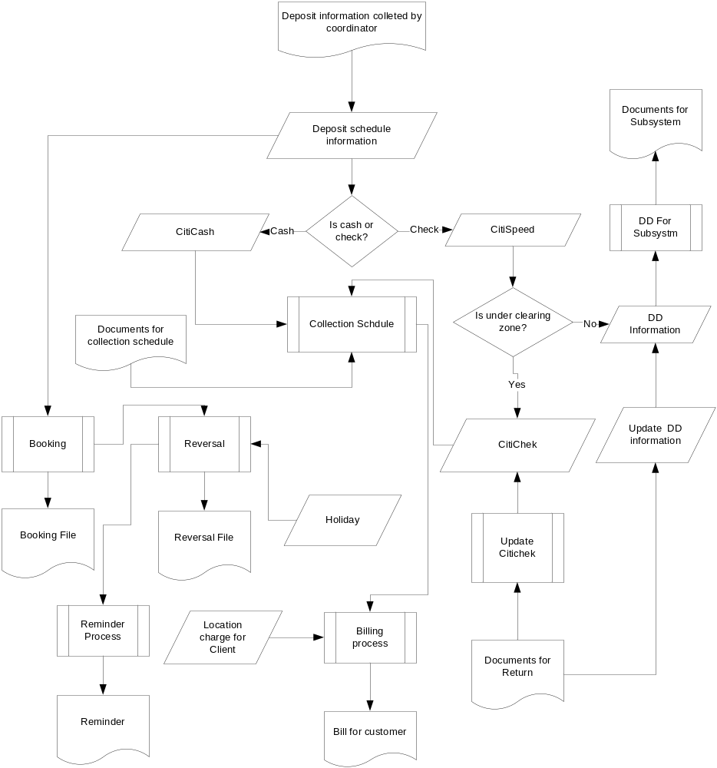

Lookup Input

- Client Information
- Bank Information
- Branch Information
- Correspond Bank Information
- Location Information
- Zone Information
- Reject/Return Information
- Entry Location
- BBK Account Information
- Holiday Information
- Location Charge
- Deposit Schedule Stock

Primary Input

- Deposit Schedule Information
- Cash Detail Information
- Speed Detail Information
- Check Detail Information
- Collection Schedule Information
- DD Detail Information
- Normal Collection Information

Process:
- Flex File Generation
- IBBS Booking
- IBBS Reversal
- Billing
- Reminder

Output (Reports)

- Reminder
- Monthly Bill
- Check Deposit Manifold
- Check For Collection
- Anywhere Funding
- Check Return Report
- Anywhere Reject
- Anywhere Return
- Cash and Speed Summery Report
- Cash Deposit Report
- Speed Deposit Report
- Speed Return Report
- Check Deposit Details Report
- Anywhere Processing
- Anywhere Funding
- Anywhere Outstanding
- Consolidated Speed Report
- Consolidated Bank Deposit
- Check Manifold Reprint
- Check For Collection Reprin

Text Report Generation
1. Speed deposit
2. Speed return
3. Check deposit
4. Cash deposit
5. Speed and citicash summery
6. Anywhere funding
7. Anywhere outstanding

Deposit Schedule Information

Deposit information like client code, client name, location code, location name, bank code, bank name which are selected by user. Moreover these users have to put deposit code, deposit date, total check, total check amount, total cash amount. After clicking on save button these information is saved on database for further process. Sequence diagram of Deposit Schedule is given below:
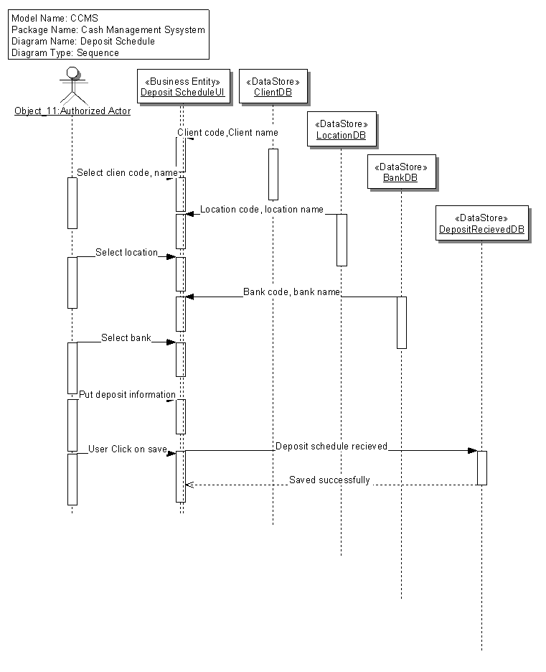

Cash Detail Information
By this form user can update cash detail formation by selecting previously entered data. When he/she put only deposit code then it’s correspond information would be shown like client, location and bank information. Users only have to put slip date, cash reference number and customer reference number. Within clicking on update button this information are updated on database. Sequence diagram of cash detail information is given below:

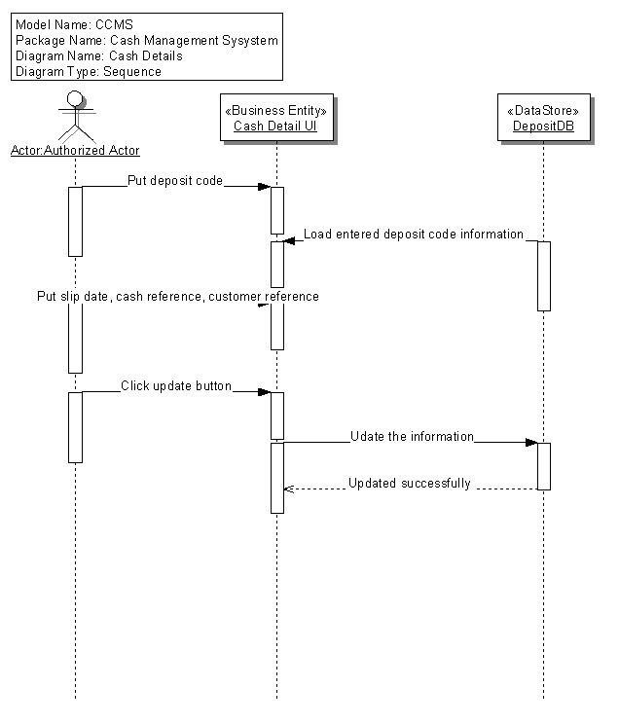

Speed Detail Information
Any authorized employee of Citibank can put deposit code into the system and immediately load the information corresponding deposit code. Then user can put slip no, date, drawer bank, branch, total number of check, total check amount and details information regarding individual check like check number, check amount, check reference number and customer reference number. When he/she click on “Save” button, all information would be saved on database for further processing. Sequence diagram of speed detail Information is given below:

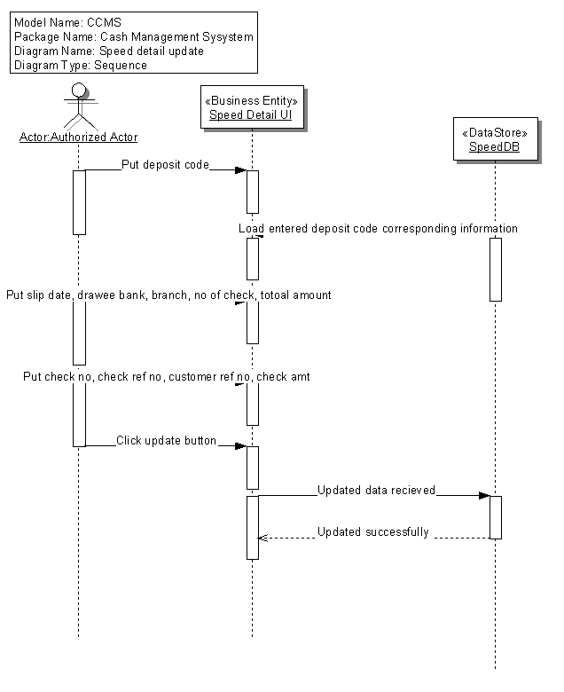
Check Detail Information

User can maintain check information using this form. User should put deposit slip no, client no, slips date, value date, deposit location customer reference number, total checks number and total check amount. User also keep track of each check like check drawer, drawee bank, branch, location, clearing zone, check type, check reference number, check number, check date, reject code, check amount.
By clicking on save button data will be sent to database. The sequence diagram of the check detail information form is given below:

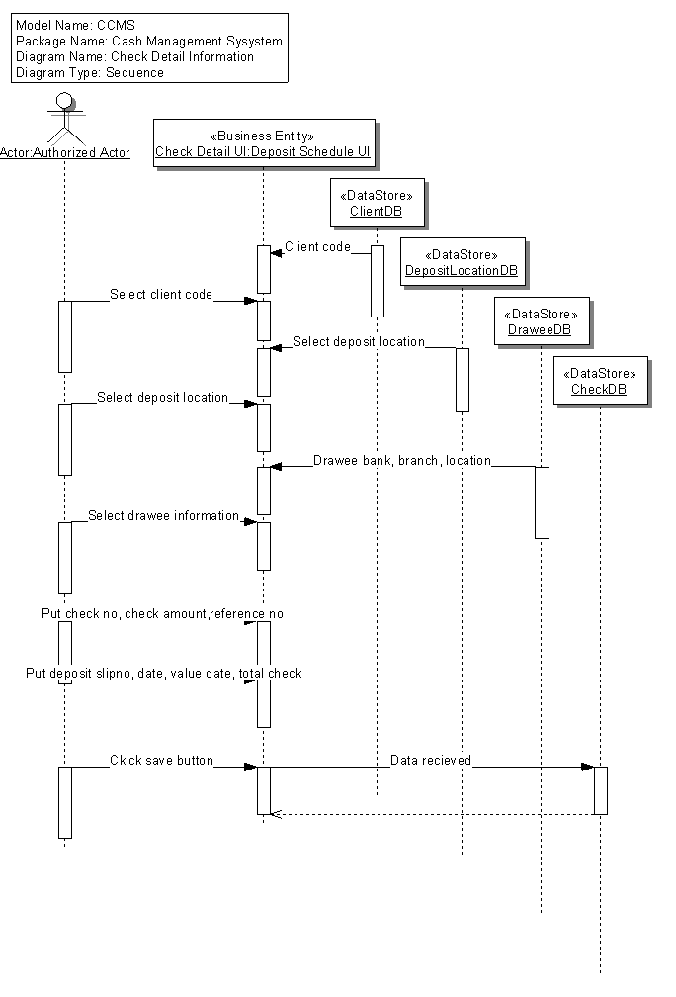

Collection Information
The correspondent will collect the information about check which is already honored or dishonored. With this form user can put information into the system which is very important e.g. collection schedule code, schedule date, location, correspond bank code, deposit schedule code, cash amount, number of check and check amount. The sequence diagram of this form is given below:

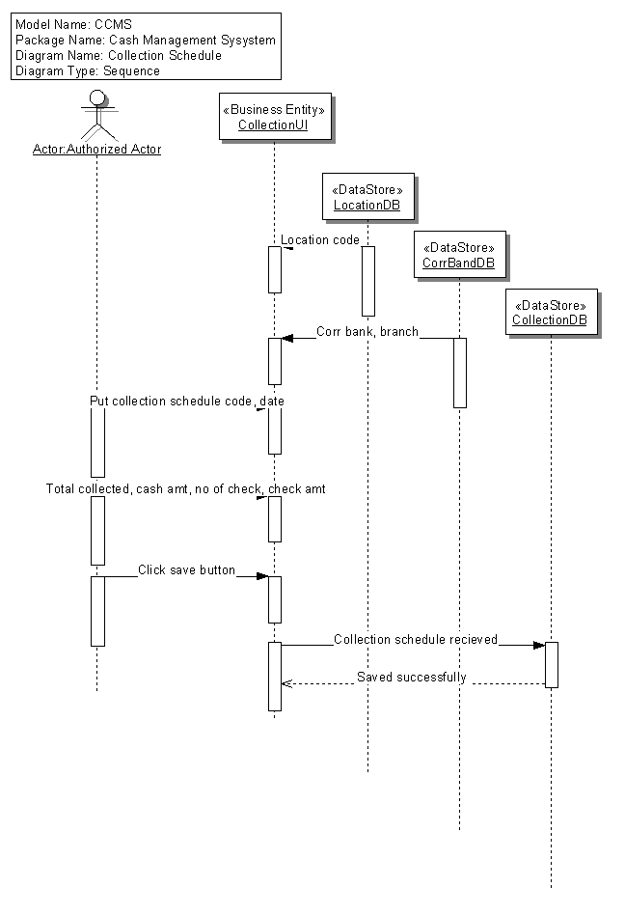

DD Information:
User will also enter other necessary information, i.e. deposit code, entry date, DD number, DD date, bank, branch, location, drawee, DD amount. After clicking on “save” button, this information will be saved. Sequence diagram of DD information is given below:

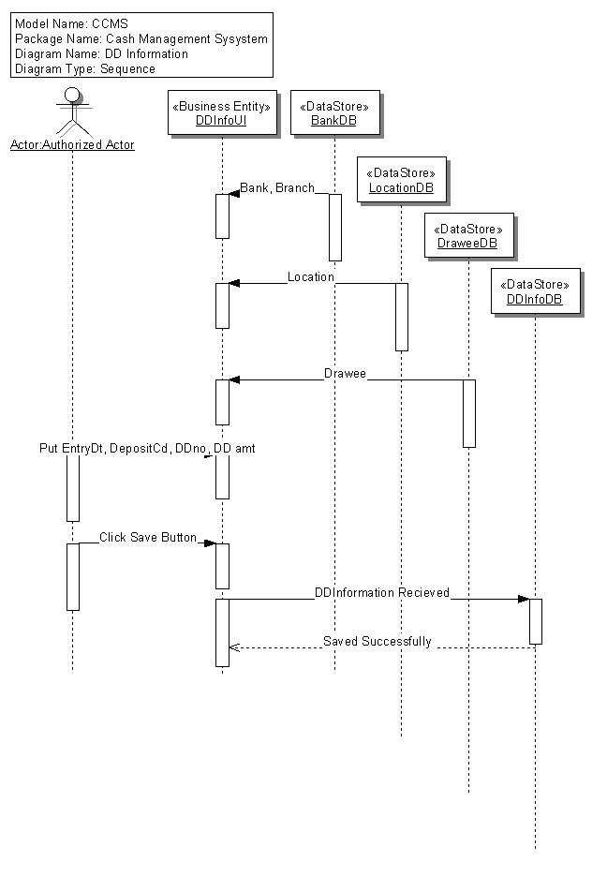

Normal Collection Return
Check status is updated if returned from clearing house. While user enters reference number and check number system automatically return information regarding given reference number and check number. After entering return code when user clicks on update button, check status is updated. Sequence diagram of normal collection return is given below:

